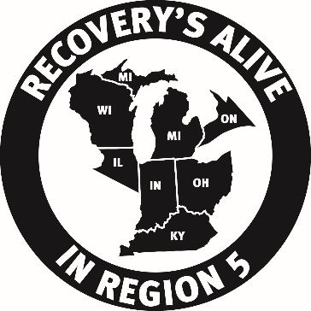
Format for Submission of Proposed
Region 5 BYLAWS Amendments

Amendments to the Region 5 Bylaws may be proposed by any Registered Group or Intergroup of Region 5, Region 5 Committee, or Voting Representative of the Region 5 Assembly and shall be submitted to the Region 5 Chair and the Region 5 Secretary. The proposed amendment will then be given to the Bylaws Committee to review.

Use this as a guide to fill out the form on the next page.

Date:
TO AMEND:
Article number and name, section number and name, paragraph number and name, by (description of the change or statement of action to be taken).

CURRENT WORDING
Article # - Title
Section # - Title

Write out current wording.

PROPOSED WORDING
Article # - Title
Section # - Title

Write out the combination of the current and the proposed wording.
Strikethrough words to be omitted like this.
Underscore words to be inserted like this.

SUBMITTED BY:
Appropriate values here would be one of the following: Name of the Region 5 Group, Intergroup, Committee, or Representative.

Please also include the following:
Contact Name: Phone #: Email Address:

INTENT:
State clearly the purpose of the motion.

IMPLEMENTATION:
How would this motion/change be carried out?

COST:
$ amount (if known).

RATIONALE:
Reason for submitting motion, including relevant background information, problems addressed by this motion, and alternatives to this motion that were considered. (Please limit to one page.)

Submit to the Region 5 Chair and the Region 5 Secretary.

Region 5 Bylaws Amendment Form

Date:

MOVE TO AMEND:

CURRENT WORDING:

PROPOSED WORDING:

SUBMITTED BY:

INTENT:

IMPLEMENTATION:

COST:

RATIONALE:

